WEBSITE DOCUMENTATION
1.(a)MAIN OBJECTIVE:
-To provide customers with an easy and convenient online platform to view, choose, and purchase sportwear and equipment for different sports.
GOALS:
-To provide customers with product information so that they can see prices, types of product and different descriptions so that they make better choices before buying.
-To allow customers from different locations to access this website and not limit the business to just one area.
-Increase sales by allowing customers to purchase goods online anytime, which helps the business to make money.
b(i)THE TARGET AUDIENCE
-It will include young children, teenagers, and adults who are more into sports and physical activities. This platform will provide sportwear and equipment for beginners and professionals for this variety of people.

(ii)DEMOGRAPHIC: This website will offer a variety of sportwear and equipment that is suitable for all genders and certain age range, ensuring that everyone can find products that meet their needs and preferences.
GENDER:
-Male
-Female
AGE RANGE:
9 to 12yrs – Kids
14 to 20yrs – Teens
21 to 30yrs – Youth
Above 30yrs – Adults

(iii)TECHNICAL BRIEF
-The website is designed using HTML, CSS, and JavaScript.
-It will include a navigation menu.
-A contact and feedback forms will be provided. JavaScript will be used to validate user input in those forms, by ensuring the correct information is entered before submission.
2.INFORMATION DESIGN AND TAXONOMY
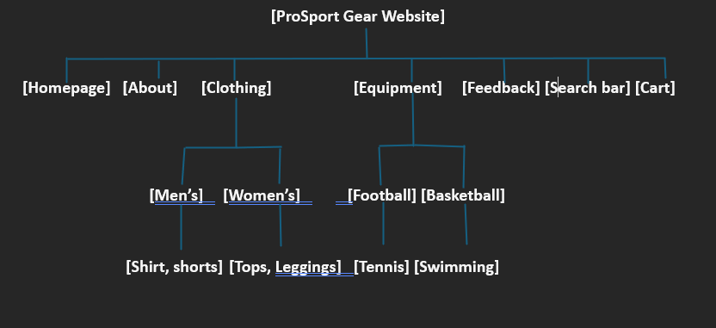
3.TECHNICAL BRIEF: I will be using the following software and graphics tools to design my website.
(i)Canvas- I will be using it at the beginning of the project to design e ProSport Gear logo. It will help me create simple graphics and design the perfect visual identity for the website.
(ii)Git-I will be using it to write and edit the website code, throughout the development process and create HTML structures, apply CSS styling, and JavaScript.
(iii)Web Browser- I will be using it to test and preview my website, after writing the code in Git to check if it works fine and see how it looks from a user viewpoint.
(iv)Bootstrap- I will use it during the design stage to make my website look more responsive and professional.

